Module 6:
Informal Observations
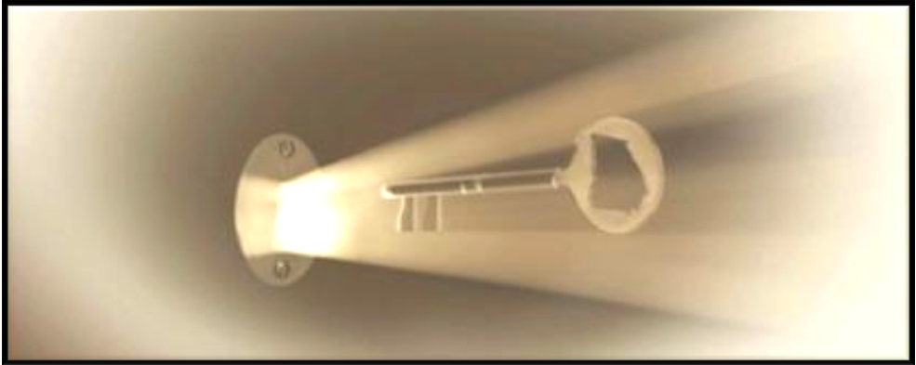

Slide 1 | 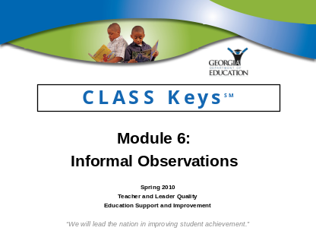 | This module details the process of collecting evidence and providing feedback on informal observations. At a minimum, the following modules should be completed before beginning Module 6:  - Module 1: Content and Structure  - Module 2: Overview of the Evaluation Process should be completed prior to delivery of this module.
Slide 2 | 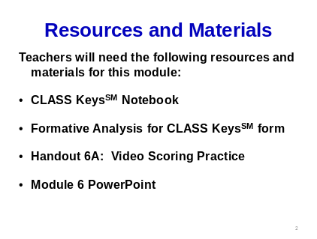 | To complete Module 6, each teacher will need:  - CLASS KeysSM notebook  - Formative Analysis for CLASS KeysSM form  - Handout 6A: Video Scoring Practice  - Module 6 PowerPoint  Facilitators will need speakers for their computers and the Middle School ELA Video Clip from the accompanying CLASS KeysSM CD to present this module.
Slide 3 | 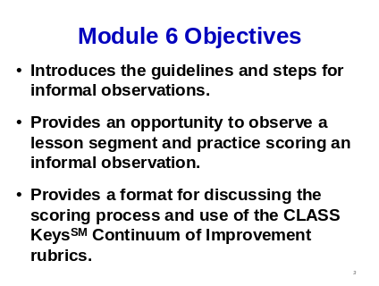 | Module 6:  - Explains the guidelines and steps for conducting an informal observation.  - Provides teachers an opportunity to step into the role of an evaluator by performing an informal observation and practice the scoring process.  - Provides a format for discussion of the scoring process and create an understanding of the importance of developing a common language within the school.
Slide 4 | 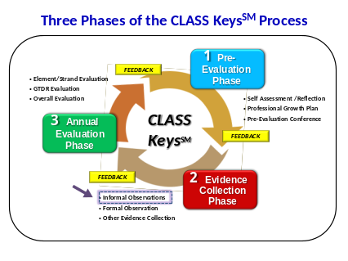 | This graphic shows the three phases of the CLASS KeysSM Process.  During Phase 2: Evidence Collection, evaluators collect evidence from observations, meetings, conferences, artifacts, and examination of teacher and student products.  The three phases in many ways represent the three kinds of assessment: Diagnostic (Phase 1), Formative (Phase 2), and Summative (Phase 3).  The informal observations are an important component of evidence collection. They provide evaluators with a means for giving teachers specific feedback, and they are factored into the annual evaluation.

Slide 5 | 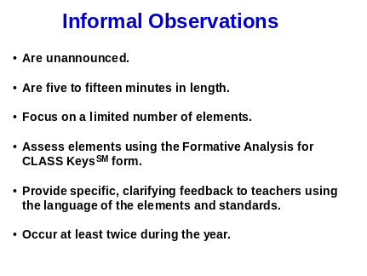 | - Informal observations are unannounced and are 5 – 15 minutes in length.  - Informal observations focus on a limited number of elements that can be observed during a short period of time.  - Teachers receive feedback on the Formative Analysis for CLASS KeysSM form within five (5) working days of the observation.  - Two informal observations are required prior to the annual evaluation – one before the formal observation and one following the formal observation.  - Districts and schools may determine expectations regarding the number of informal observations beyond the two (2) required in the CLASS KeysSM process.
Slide 6 | 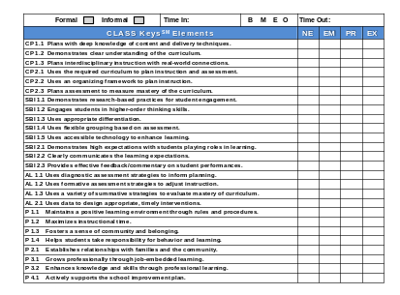  Facilitator’s Note: Be sure  that each teacher has a Formative Analysis for  CLASS KeysSM form. | The Formative Analysis for CLASS KeysSM form shown on this slide and included in the handouts is used for both formal and informal observations.  The evaluator will complete the information at the top and indicate that this is an informal observation. Double clicking on the blocks will allow an “X” to be inserted.  There is a space to record the “Time In” and “Time Out” as well as a method to record which lesson segment is being observed.  B = Beginning of the lesson  M = Middle of the lesson  E = End of the lesson  O = Outside the classroom: conferences, meetings, viewing of student or teacher products, etc.  Ideally, the evaluator would view different lesson segments (B, M, E) during the year.  Twenty-six (26) elements are listed on the form.  These 26 elements are found in the CLASS KeysSM notebook that the evaluator will use to assess the elements observed during the informal observation.  Scoring of the assessed elements is done by double clicking on the blocks to insert an X.  The two elements of the Student Achievement Strand are not listed on the form because they are evaluated only at the annual evaluation.

Slide 7 | 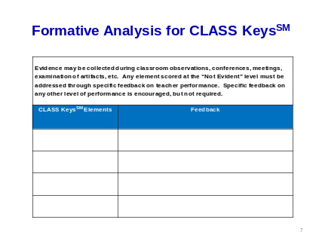 | The back of the form is used for written feedback on the informal observation.  - When an element is scored as NOT EVIDENT, the evaluator will provide specific written feedback.  - If an element is not observed during an informal observation, the box is left blank.  - Feedback on the Formative Analysis for CLASS KeysSM form may be sent to the teacher electronically, placed in the teacher’s mailbox, or discussed at a face-to-face conference.  - A post-observation conference is not required for informal observations but may be requested by either the evaluator or the teacher to discuss the scoring or feedback.  - The teacher should sign and return the form to the evaluator. The teacher may add or attach comments if desired.
Slide 8 | 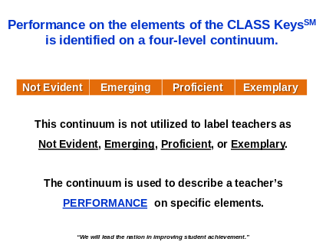 | Performance on the elements is scored on the Continuum of Improvement rubrics. There are four (4) performance levels: NOT EVIDENT, EMERGING, PROFICIENT, and EXEMPLARY.  The Continuum of Improvement rubrics are not used to label teachers. They are used to describe the teacher’s performance on specific elements.
Slide 9 | 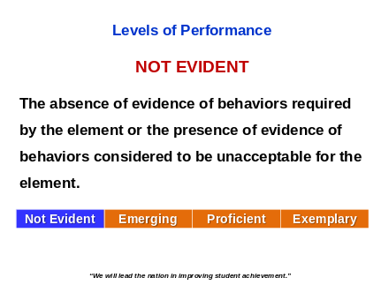 | A NOT EVIDENT score indicates that there is an absence of evidence of behaviors required by the element or that there is evidence of behaviors considered to be unacceptable for the element.  In some lessons, the element is scored as NOT EVIDENT because it should have been used by the teacher to enhance learning.  In other lessons, the element is scored as NOT EVIDENT because the performance is an ineffective demonstration of the element.
Slide 10 | 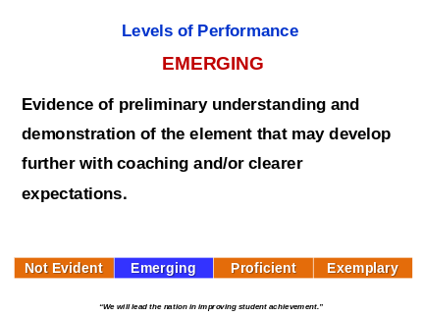 | An EMERGING score indicates that the teacher is working toward the proficient level for the element. The teacher has shown some positive attributes but also has deficits.  The teacher may benefit from coaching and/or clearer expectations.
Slide 11 | 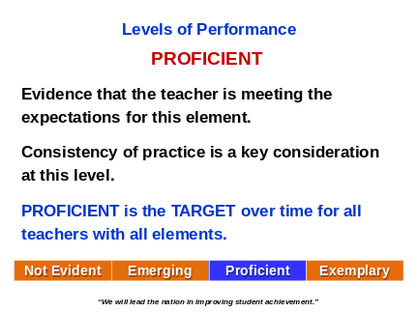 | A PROFICIENT score indicates that the teacher is meeting the TARGET or expectations for this element.  Consistency of practice is the key consideration at this level.  PROFICIENT is the target - over time - for all 26 of the CLASS KeysSM elements.
Slide 12 | 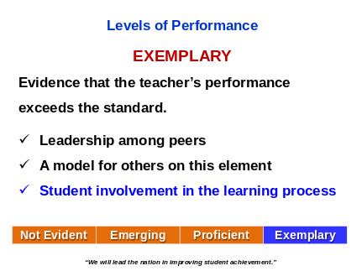 | The fourth level of performance is EXEMPLARY. How does EXEMPLARY differ from PROFICIENT?  EXEMPLARY is defined as performance that exceeds the standard. Some examples include:  - Leadership among peers  - A model for others on this element  - Student involvement in the learning process
Slide 13 | 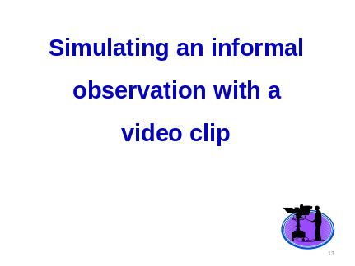 | Today’s activity is for learning purposes. Teachers will step into the role of the evaluator conducting an informal observation.  The classroom video for this activity is 11 minutes long. Informal observations are generally 5 – 15 minutes in length.  What are the purposes of this activity?  - Simulates steps of an informal observation  - Establishes clear expectations and common understanding of elements  - Improves common understanding within a school  What will not be evaluated in this video that an evaluator normally has access to view?  - Lesson and/or unit plans  - Pre and Post Assessments  - Transitions between activities  - Previous lessons in the unit
Slide 14 | 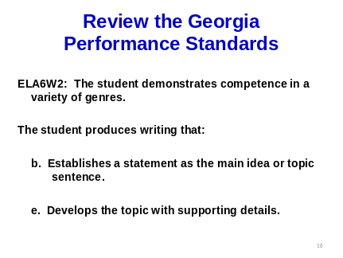 | Knowing the standards and elements being taught is helpful to the evaluator or any observer.  This example from “The Human Essay” lesson from the Graduation Counts DVD #6 presents Georgia Performance Standard ELA6W2:  The student demonstrates competence in a variety of genres is the standard taught during the lesson.  Two elements of the standard are emphasized:  - Establishes a statement as the main idea or topic sentence.  - Develops the topic with supporting details.
Slide 15 | 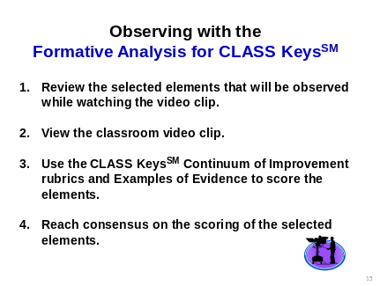  Note to Facilitator:  Be sure that the video clip will play on the computer and that speakers are connected prior  to starting the module.  Distribute Handout 6A: Video Scoring Practice. | - During the training activity, look only for the selected elements on Handout 6A: Video Scoring Practice.  The video shows a middle school language arts classroom. It is a co-taught class with a general education teacher and a special education teacher. The video is from the “Human Essay” lesson on the Graduation Counts DVD #6.  - Consider information about the collaborative setting, but only score the performance of the general education teacher.

Slide 16 | 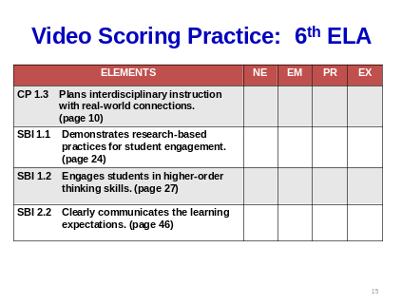  Divide the teachers into small groups (3-5) for this video scoring activity.  Note to the Facilitator: Show the video clip. Allow time for the teachers to collaboratively score the elements and reach consensus in their groups. | This slide shows the elements to observe and score. For learning purposes and also to control time, only four elements have been preselected for this activity.  Other elements will be observed but only the selected elements should be scored.  Notice the CLASS KeysSM notebook page numbers in parentheses. Look at the pages in order to learn more about the elements.  - Following the observation, discuss the selected elements with your collaborative group.  - Refer to the pages listed in the CLASS KeysSM notebook to score the elements. Review the Continuum of Improvement rubrics as well as Examples of Evidence.  In collaborative groups, reach consensus on the scores for the selected elements.

Slide 17 | 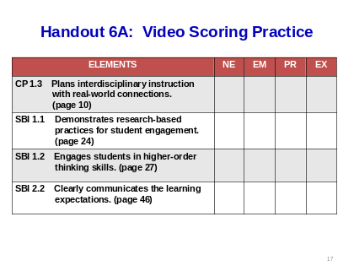  The facilitator will need  to closely monitor time and  the conversation during this segment. | Ask groups to share their thoughts on the scoring of CP 1.3: Plans interdisciplinary instruction with real-world connections.  What interdisciplinary instruction took place during the lesson? (Preparation for expository writing was based on content learned in a science lesson about rocks.)  The score for this element is PROFICIENT.  Ask groups to share their thoughts on the scoring of the next element SBI 1.1: Demonstrates research-based practices for student engagement.  The score for this element is PROFICIENT.  What were some of the research-based practices demonstrated during the lesson? (Modeling, identifying prior knowledge, providing feedback, summarizing, explaining in multiple ways.)  Ask groups to share their thoughts on the scoring of the next element SBI 1.2: Engages students in higher-order thinking skills.  What kinds of questions were predominant during the lesson? (Mostly fact and/or recall.)  The score for this element is EMERGING.  Ask groups to share their thoughts of the scoring of element SBI 2.2: The teacher clearly communicates the learning expectations. (While there was an essential question, little time was spent on language of the standard and elements.)  The score for this element is EMERGING.
Slide 18 | 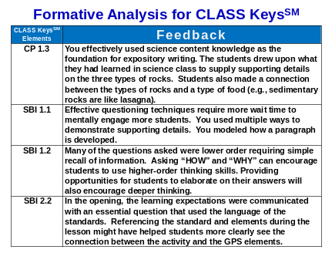 | Read the sample feedback provided for the four elements.  What are the advantages of this qualitative feedback on teacher performance compared to the feedback teachers receive from a checklist of artifacts? (Is the essential question posted? Does the teacher have a word wall?)  Careful review of this sample feedback provides reasons to study weakest elements. Using the rubrics and examples of evidence provides clear directions for next steps.
Slide 19 | 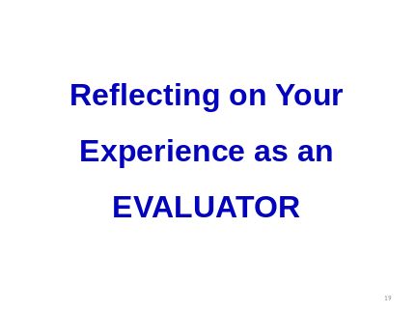  Facilitator’s Notes:  - Select questions for discussion based on your group.  - Remind teachers that evaluators may begin “practice” observations in pairs as a way to reach consistency in scoring. | Guiding Questions for Discussion:  What did it feel like to walk in the shoes of an evaluator?  Were there any elements that were difficult to observe or score?  How did your group use the CLASS KeysSM notebook to reach consensus?  Imagine trying to score a teacher’s performance without rubrics that define clear expectations. Scoring is much more subjective without a frame of reference.  The clarity provided by CLASS KeysSM rubrics and evidence will not put teachers in the position of being mind readers. They will not have to guess what their evaluators are looking for in their classrooms.

Slide 20 | 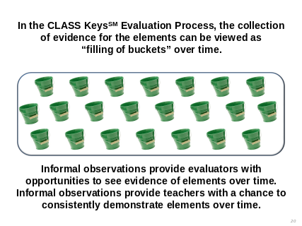 | During the year, the evaluator will collect evidence on the elements. If elements are not observed, the evaluator may coach the teacher and/or provide opportunities to observe more elements.  Teachers should carefully review feedback on the Formative Analysis for CLASS KeysSM form to be aware of elements that have been observed.  Think of informal observations as being a type of formative assessment. It is the assessment of learning along the way to the annual evaluation. Reviewing feedback will encourage development of next steps.  Besides classroom observations, teachers may receive feedback on elements based on evidence from meetings, conferences, artifacts and examination of student and adult products.  For example, teachers might receive positive feedback on mentoring other teachers, working effectively with families, or demonstrating technology.  Teachers may also receive corrective feedback about specific elements.

Slide 1 | 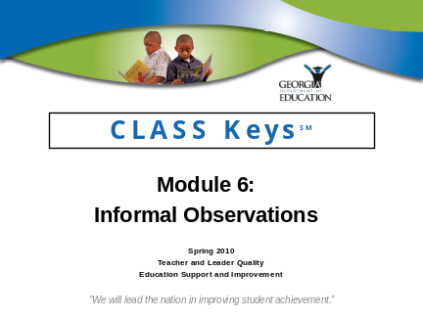 | ___________________________________  ___________________________________  ___________________________________  ___________________________________  ___________________________________  ___________________________________  ___________________________________
Slide 2 | 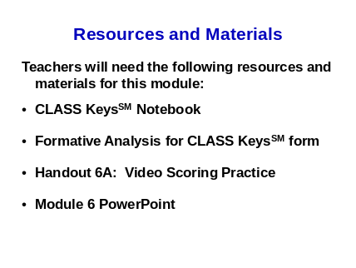 | ___________________________________  ___________________________________  ___________________________________  ___________________________________  ___________________________________  ___________________________________  ___________________________________
Slide 3 | 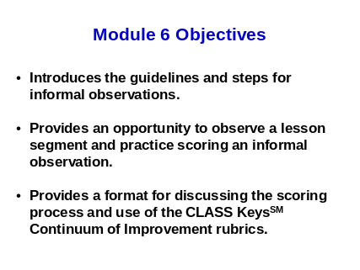 | ___________________________________  ___________________________________  ___________________________________  ___________________________________  ___________________________________  ___________________________________  ___________________________________
Slide 4 | 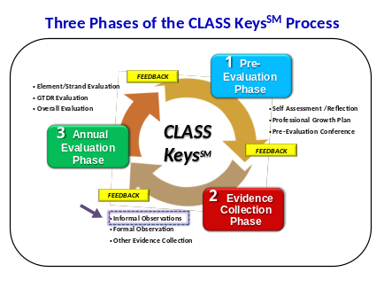 | ___________________________________  ___________________________________  ___________________________________  ___________________________________  ___________________________________  ___________________________________  ___________________________________
Slide 5 | 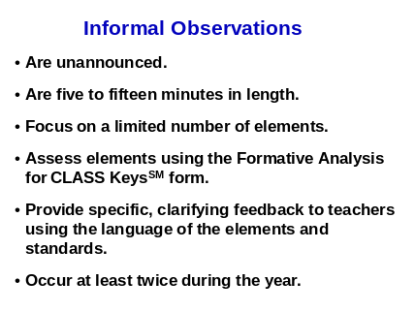 | ___________________________________  ___________________________________  ___________________________________  ___________________________________  ___________________________________  ___________________________________  ___________________________________
Slide 6 | 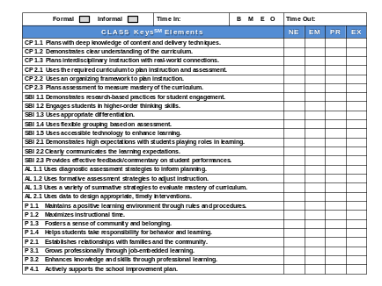 | ___________________________________  ___________________________________  ___________________________________  ___________________________________  ___________________________________  ___________________________________  ___________________________________
Slide 7 | 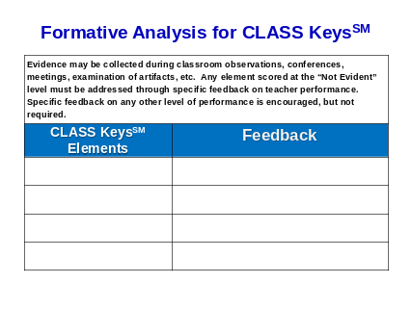 | ___________________________________  ___________________________________  ___________________________________  ___________________________________  ___________________________________  ___________________________________  ___________________________________
Slide 8 | 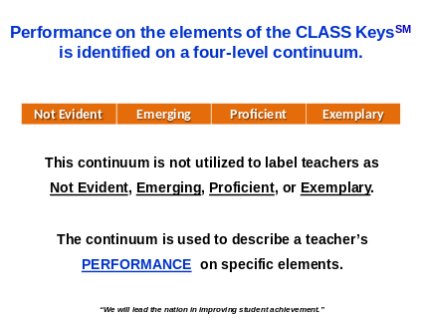 | ___________________________________  ___________________________________  ___________________________________  ___________________________________  ___________________________________  ___________________________________  ___________________________________
Slide 9 | 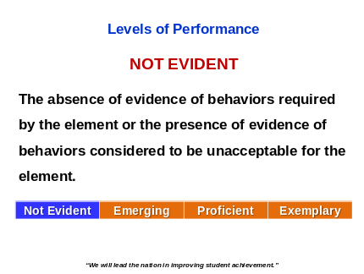 | ___________________________________  ___________________________________  ___________________________________  ___________________________________  ___________________________________  ___________________________________  ___________________________________
Slide 10 | 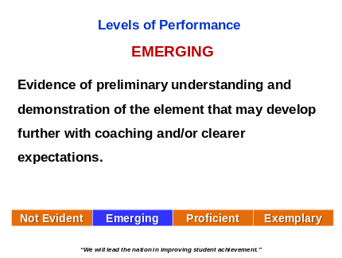 | ___________________________________  ___________________________________  ___________________________________  ___________________________________  ___________________________________  ___________________________________  ___________________________________
Slide 11 | 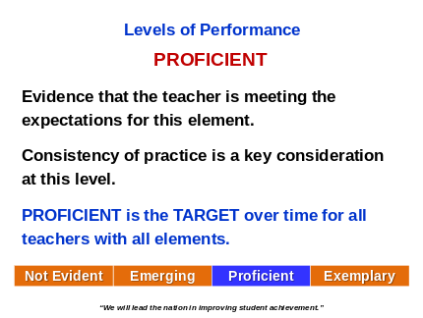 | ___________________________________  ___________________________________  ___________________________________  ___________________________________  ___________________________________  ___________________________________  ___________________________________
Slide 12 | 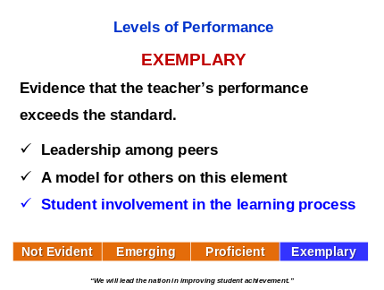 | ___________________________________  ___________________________________  ___________________________________  ___________________________________  ___________________________________  ___________________________________  ___________________________________
Slide 13 | 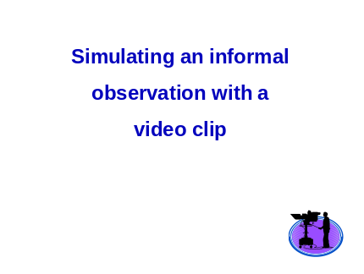 | ___________________________________  ___________________________________  ___________________________________  ___________________________________  ___________________________________  ___________________________________  ___________________________________
Slide 14 | 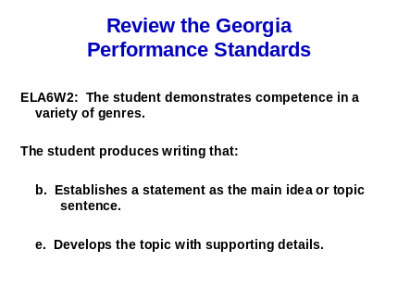 | ___________________________________  ___________________________________  ___________________________________  ___________________________________  ___________________________________  ___________________________________  ___________________________________
Slide 15 | 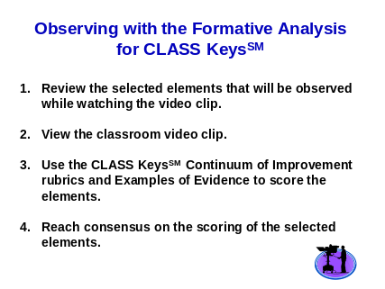 | ___________________________________  ___________________________________  ___________________________________  ___________________________________  ___________________________________  ___________________________________  ___________________________________
Slide 16 | 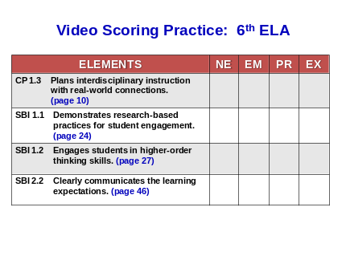 | ___________________________________  ___________________________________  ___________________________________  ___________________________________  ___________________________________  ___________________________________  ___________________________________
Slide 17 | 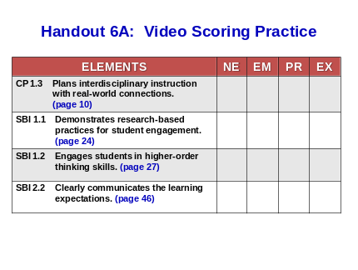 | ___________________________________  ___________________________________  ___________________________________  ___________________________________  ___________________________________  ___________________________________  ___________________________________
Slide 18 | 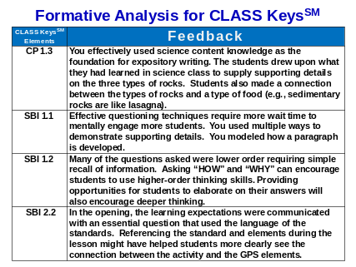 | ___________________________________  ___________________________________  ___________________________________  ___________________________________  ___________________________________  ___________________________________  ___________________________________
Slide 19 | 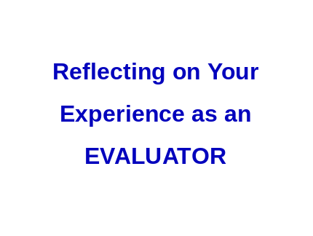 | ___________________________________  ___________________________________  ___________________________________  ___________________________________  ___________________________________  ___________________________________  ___________________________________
Slide 20 | 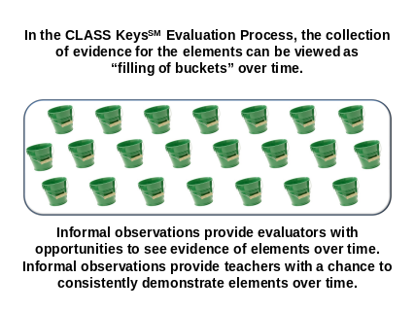 | ___________________________________  ___________________________________  ___________________________________  ___________________________________  ___________________________________  ___________________________________  ___________________________________

Teacher: |  | School/District:
Grade/Content: |  | Evaluator:
Observation Date: |  | Evaluator Signature:
Formal Informal | Time In: |  | B M E O | Time Out:
CLASS KeysSM Elements |  |  |  | NE | EM | PR | EX
CP 1.1 Plans with deep knowledge of content and delivery techniques.
CP 1.2 Demonstrates clear understanding of the curriculum.
CP 1.3 Plans interdisciplinary instruction with real-world connections.
CP 2.1 Uses the required curriculum to plan instruction and assessment.
CP 2.2 Uses an organizing framework to plan instruction.
CP 2.3 Plans assessment to measure mastery of the curriculum.
SBI 1.1 Demonstrates research-based practices for student engagement.
SBI 1.2 Engages students in higher-order thinking skills.
SBI 1.3 Uses appropriate differentiation.
SBI 1.4 Uses flexible grouping based on assessment.
SBI 1.5 Uses accessible technology to enhance learning.
SBI 2.1 Demonstrates high expectations with students playing roles in learning.
SBI 2.2 Clearly communicates the learning expectations.
SBI 2.3 Provides effective feedback/commentary on student performances.
AL 1.1 Uses diagnostic assessment strategies to inform planning.
AL 1.2 Uses formative assessment strategies to adjust instruction.
AL 1.3 Uses a variety of summative strategies to evaluate mastery of curriculum.

AL 2.1 Uses data to design appropriate, timely interventions.
P 1.1 Maintains a positive learning environment through rules and procedures.
P 1.2 Maximizes instructional time.
P 1.3 Fosters a sense of community and belonging.
P 1.4 Helps students take responsibility for behavior and learning.
P 2.1 Establishes relationships with families and the community.
P 3.1 Grows professionally through job-embedded learning.
P 3.2 Enhances knowledge and skills through professional learning.
P 4.1 Actively supports the school improvement plan.

(NE = Not Evident EM = Emerging PR = Proficient EX = Exemplary)
Teacher Signature: _______________________________ Date: _____________________
Evidence may be collected during classroom observations, conferences, meetings, examination of artifacts, etc. Any element scored at the “Not Evident” level must be addressed through specific feedback on teacher performance. Specific feedback on any other level of performance is encouraged, but not required.
CLASS KeysSM Elements | Feedback

ELEMENTS | NE | EM | PR | EX
CP 1.3 Plans interdisciplinary instruction with real-world connections. (page 10)
SBI 1.1 Demonstrates research-based practices for student engagement. (page 24)
SBI 1.2 Engages students in higher-order thinking skills. (page 27)
SBI 2.2 Clearly communicates the learning expectations. (page 46)
Handout 6A: Video Scoring Practice

